Chapter 6, Problem 62.

Consider the circuit in Fig. 6.84. Given that v(t) = 12e^{-3t} mV for t > 0 and
i₁(0) = –10 mA, find: (a) i₂(0), (b) i₁(t) and i₂(t).

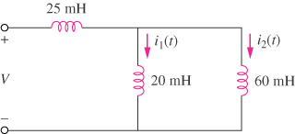
v(t)

Figure 6.84
For Prob. 6.62.

